Interactive Quiz – Application

1. INTRODUCTION
The Live Quiz Platform is a web-based application designed to provide users with an engaging and interactive quiz experience. It allows users to register, log in, and participate in quizzes in real time. Unlike traditional quiz systems with fixed questions, this platform fetches questions dynamically from a quiz API, ensuring variety and freshness each time.
The application features a timer-based quiz, automatic scoring, and instant feedback, enhancing both user engagement and learning outcomes.
The Interactive Quiz Application is designed for educational institutions seeking to enhance student engagement through an intuitive and visually appealing quiz platform.
The system allows users to register, create, and participate in quizzes while receiving instant feedback and scores. Unlike conventional quiz platforms, this application emphasizes user experience, responsiveness, and interactivity.

Submission Member :
Vivek Shashikant Shende
Intern ID : 3166
Position: Front-End Development Intern
Duration: 1st November 2025 to 30th November 2025
Project Name : Project 4 - Interactive Quiz Application

2. PROBLEM STATEMENT

An educational institution wants to engage students with an interactive quiz application. Existing quiz platforms may lack a modern and intuitive user interface.
Existing online quiz platforms often lack modern design and dynamic functionality. Most use static question sets, which can make them repetitive and predictable. Educational institutions and learners need a lightweight, responsive, and dynamic quiz system that updates questions automatically, provides instant scoring, and delivers a smooth user experience on any device.

3. OBJECTIVES

The main objectives of this project are:
- To design and develop an interactive and responsive quiz application using web technologies.
- To implement user registration, login, and quiz-taking functionalities.
- To integrate a Quiz API for fetching real-time questions dynamically.
- To provide instant feedback and scoring at the end of each quiz.
- To ensure the interface is accessible, user-friendly, and visually appealing.

4. SOFTWARE REQUIREMENTS

Hardware Requirements
- Processor: Intel i3 or higher
- RAM: 4 GB minimum
- Storage: 100 MB free space
- Display: Minimum 1366×768 resolution
Software Requirements
Component | Description
Operating System | Windows / macOS / Linux
Editor/IDE | Visual Studio Code
Web Browser | Google Chrome / Microsoft Edge
Languages Used | HTML, CSS, JavaScript
API Used | Open Trivia Database API (https://opentdb.com/api.php)

5. SYSTEM DESIGN

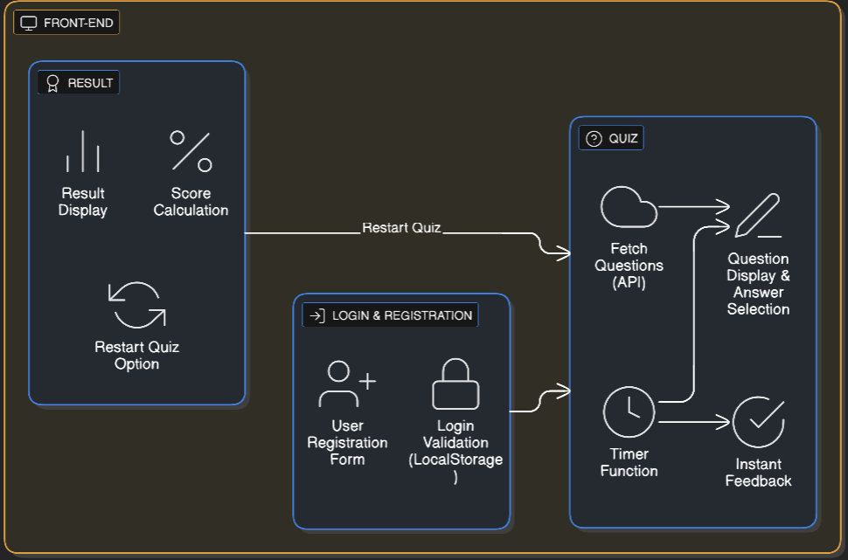
System Architecture :

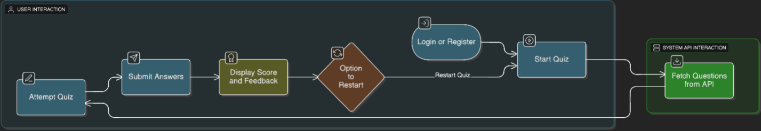
Data Flow :

6. FUNCTIONALITIES

Module | Description
Login & Registration | Allows users to create and log into an account
API-based Questions | Fetches random multiple-choice questions from Open Trivia Database API.
Quiz Timer | Displays countdown for each question to simulate real-time pressure.
Interactive Quiz Interface | Users select answers and get immediate feedback.
Scoring System | Calculates total score based on correct answers and displays at the end.
Restart Option | Allows users to restart the quiz for another attempt.

User Interface Design
Main Pages:
- Login Page – Allows user authentication with “Login” and “Register” tabs.
- Quiz Page – Displays question, timer, and options dynamically.
- Result Page – Shows final score and restart button.
Design Characteristics:
- Clean blue gradient background
- Centered quiz card for focus
- Smooth transition between questions, Responsive layout for all screen sizes
7. PROJECT OUTCOMES

- Successfully developed a real-time quiz platform using HTML, CSS, and JavaScript.
- Integrated Open Trivia API to fetch live questions dynamically.
- Implemented timed quizzes, scoring, and feedback features.
- Designed a responsive and intuitive interface for smooth user experience.

8. FUTURE ENHANCEMENTS

- Add database integration (MySQL/Firebase) for persistent user data.
- Include category and difficulty selection before starting a quiz.
- Implement a leaderboard system to display top scores.
- Add admin panel for creating custom quizzes.
- Enable dark/light mode for accessibility.

9. SCREENSHOTS
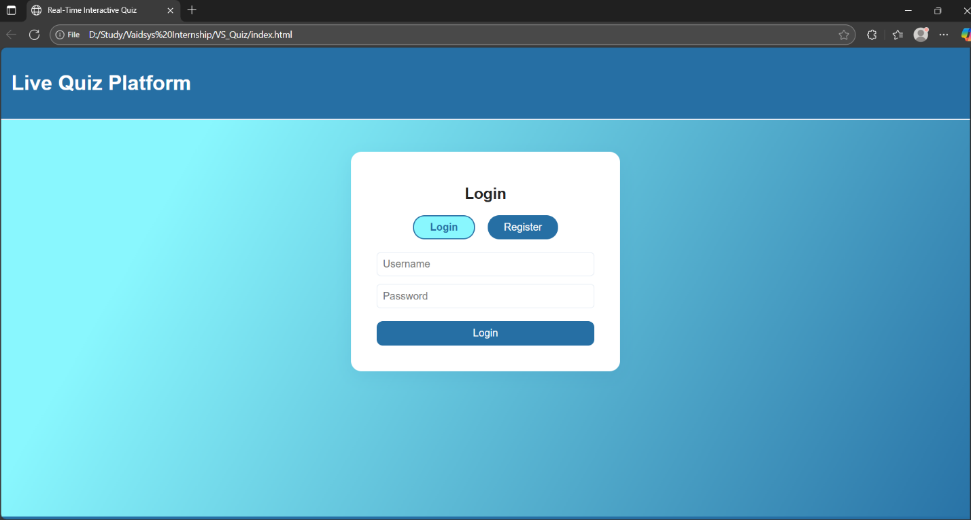

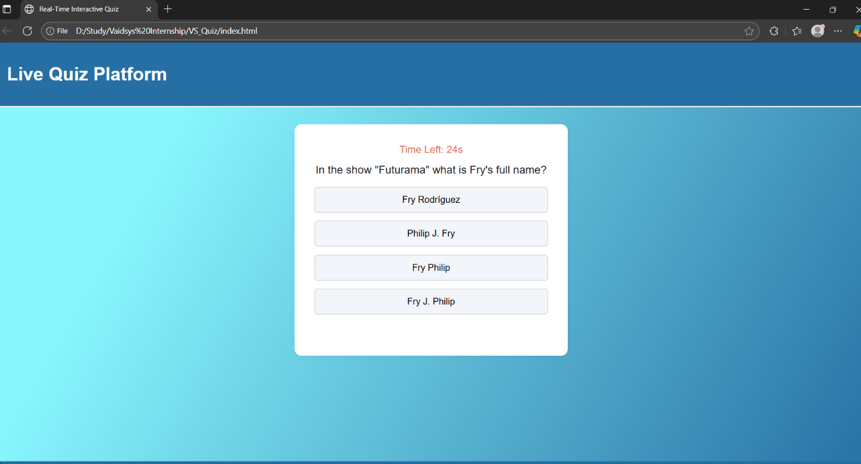

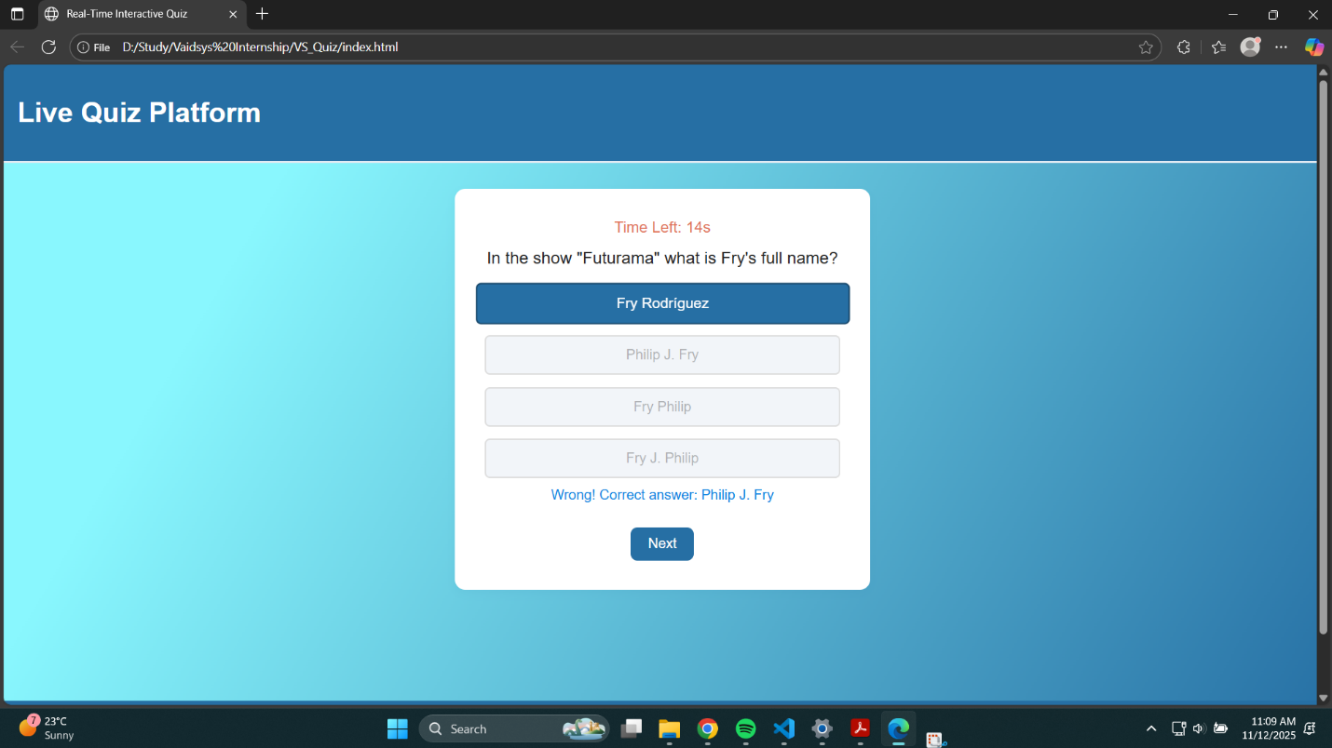

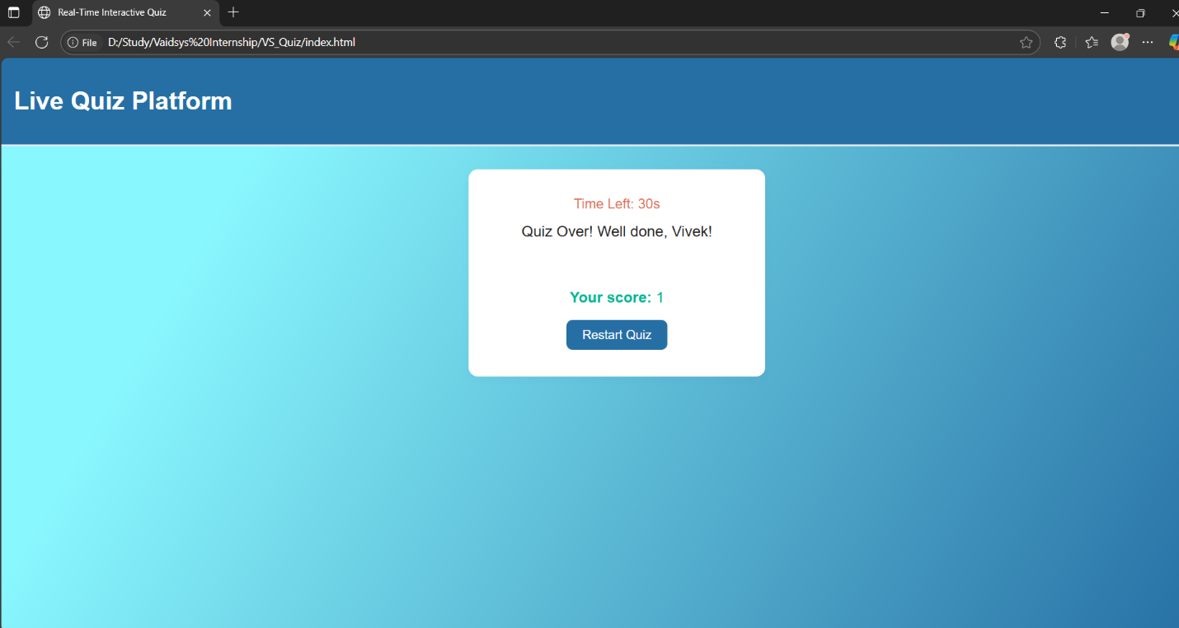
10. CONCLUSION

The Live Quiz Platform successfully meets its goal of providing an engaging, responsive, and dynamic quiz experience for users. It utilizes API-driven questions to ensure variety and real-time updates while maintaining a clean and simple interface. This project demonstrates effective use of front-end web technologies to build modern, interactive learning tools for educational purposes.

